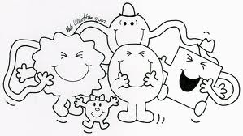

**How have the pictures told us more about this Mr Men?**

**If there is a lesson in the story, what is it?**

**Why would little children like this book? What would appeal to them?**

**What does he do in the story to be like his name or to not be like his name?**

**What is the story mainly about?**

**What is the name of your book?**

**Why is your Mr Men called that?**

**Name:**